

**Tender Proposal**

**Project : SBSA – Public Sentimental Tracker**

**18 March 2013**

Table of Contents

Introduction 3

Team Description 4

Problem Description 5

Proposed Solution 6

REQUIREMENT 6

ARCHITECTURE DESIGN 6

Querying From Front-end Application 6

Storing the FEED text for analysis 7

Service Offering 7

# Introduction

The main objective of this document is to bring forth and elaborate a proposal to tender the project, Public Sentiment Tracker), proposed to the University of Pretoria by the Standard Bank of South Africa (SBSA). It briefly describes the project objectives and requirements as understood by *The Gruners* team. It also presents an outline of the proposed solutions.

# Team Description

The Gruners is a competitive team of three students in the Department of Computer Science that have been in collaboration for the most for their undergraduate years of study. The name of the team was inspired by a Computer Science professor at the University of Pretoria, Prof. Stefan Gruner. We have, throughout our different years of undergraduate study, been exposed to numerous technologies and techniques that do not only effectively address software design and development problems, but also provide efficient solutions for current industry development problems. We rely not only on the technologies that we have learnt thus far, but we rely as well on skills such as problem-solving, systems design, decision-making, collaboration, and work-balance in order to successfully develop different kinds of efficient systems.

# Problem Description

The problem is being unable analyse and report on general topics which public sentiment based on. The organisation hence has limited intelligence on the public sentiment then public satisfaction is not met on such topic. By providing public sentiment analysis, one can pro-actively address, improve and monitor the topic at hand, allows one to gauge customer satisfaction when releasing new products, features and applications.

# Proposed Solution

## REQUIREMENT

The system should be extendable to any type of data provided by a social media site. Figure 1, below, shows that the system must generate a Sentiment index which is based on a user defined topic and show it as a graph over time.

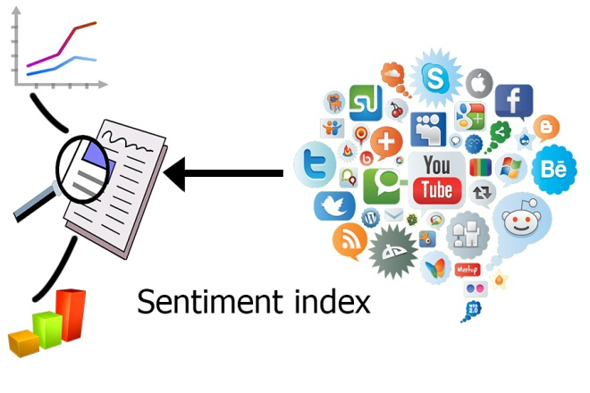

Figure 1

## ARCHITECTURE DESIGN

The sentiment analysis engine is implemented mainly on Representational State Transfer (REST). Which its key characteristic of a Web service is the explicit use of HTTP methods to denote the invocation of different operations. With the use of REST API, the following made.

### Querying From Front-end Application

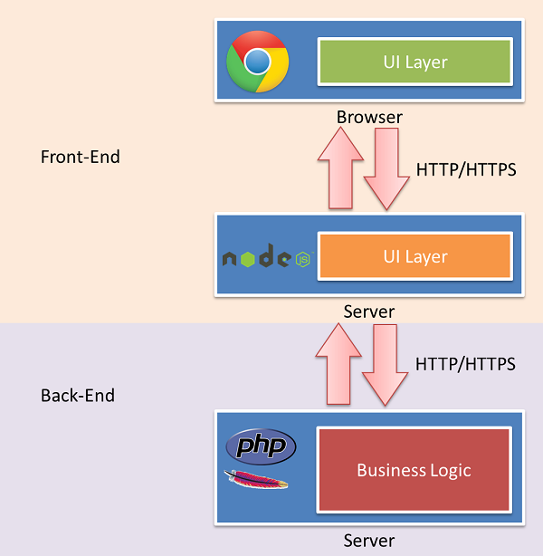

Figure 2

The front-end application is primarily working with technologies inside of a browser window, shown in figure 2. This application does the following.

* Provide input for the keywords and topic
* Interacts with sentiment analysis engine for query results
* Produce a sentiment index graph over time
* Produce a result set of text highlighting the keywords provided
* Alert on given threshold breach for that topic

### Storing the FEED text for analysis

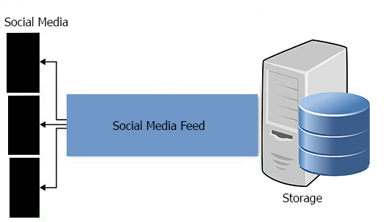

Figure 3

Figure 3, show the process storing text for analysis, the sub-process are:

* Capturing a stream of text from social media
* Provide the sentiment analysis engine with captured stream of text for analysis

## Service Offering

We offer to conceptualise and design an application for the proposed system. An application that can track and report on public sentiment given any topic across social media. This application providing a user-friendly interface and dashboard of public sentiment will allow the organisation to interactively and proactively feedback for analysis and reporting.